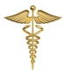
ESTD:1990 Ph:0821-2444441
MYSORE CLINICAL SOCIETY (R)
City X-Ray Complex, Sayyaji Rao Road, Mysuru-570 021

E-mail:drcsharath@hotmail.com, website:www.mediwave.net

For Kind Publication Date: 08.12.2015
70% of the Children in India are suffering from common intestinal worms said - Dr C.S.K

Children who have intestinal worms will not feel hungry, suffer from stomach aches, vomiting, diarrhea, malnutrition, anemia, anxiety and physical imbalances from this children will face difficulties in their education and future growth. 70% of the people in India is suffering from common intestinal worms Said Dr.C. Sharath Kumar, Director & Chief Fertility Surgeon, Mediwave IVF & Fertility Research Hospital, Mysore.

On the occasion of National De-worming Day as observed on 12th February 2016, Friday, at Mediwave IVF & Fertility Research Hospital, in association with Mysore Clinical Society, and Mysore Elite Round Table-256 a Free De-worming celebration & Free Medicine Camp was conducted.

Intestinal worms come through constipation, unclean toilets and environmental pollution among human beings. By providing this De-worming medication to children, general public should contribute in eradicating intestinal worms Said Dr.C.S.K

On the same occasion the Brave Soldier Hanumantahppa Koppad who took his last breath after surviving the avalanche at Jammu Kashmir, Siachen, was also remembered and new Thermostat jackets to be provided for the army men at border was also recommended, and these jackets are being manufactured in India itself and America is also importing the same thing from India for their army Said Dr.C.S.K

This camp was inaugurated by Dr. S. Gopinath Reproductive & Child Health (RCH) officer, Mysore. Said that Central and State governments are contributing highly towards public health improvisation and “today’s children are tomorrow’s citizens”, by keeping this in mind Government is providing free medication for children between the ages 1 and 19 and this happens to be the mission and vision.

Smt.Dr. Sujatha S. Rao, Obstetric & Gynecologist; Dr S Ravikumar, Chairman, Mysore Elite Round Table-256; were chief guests for the day, and Dr. M.S. Vishveshwara, Vice- President, Mysore Clinical Society and Dr.M.G.RUrs Rajyothsava Awardee, Govt. Of Karnataka were present for the day.

On the same occasion the Brave Soldier Hanumantahppa Koppad who took his last breath after surviving the avalanche at Jammu Kashmir, Siachen, was also remembered and given a minute’s silence and after Mysore Clinical society gave Rs.1001, to his family also its reach was taken care of my the society.

After the Programme free medication was provided to 60 students at “Shravana Dhoshavulla Makkala Sarkari Shaale” at Tilak nagar, Mysuru, and also for 30 students at Metagalli Govt. Higher Primary School.

Photo Caption:
Picture-1

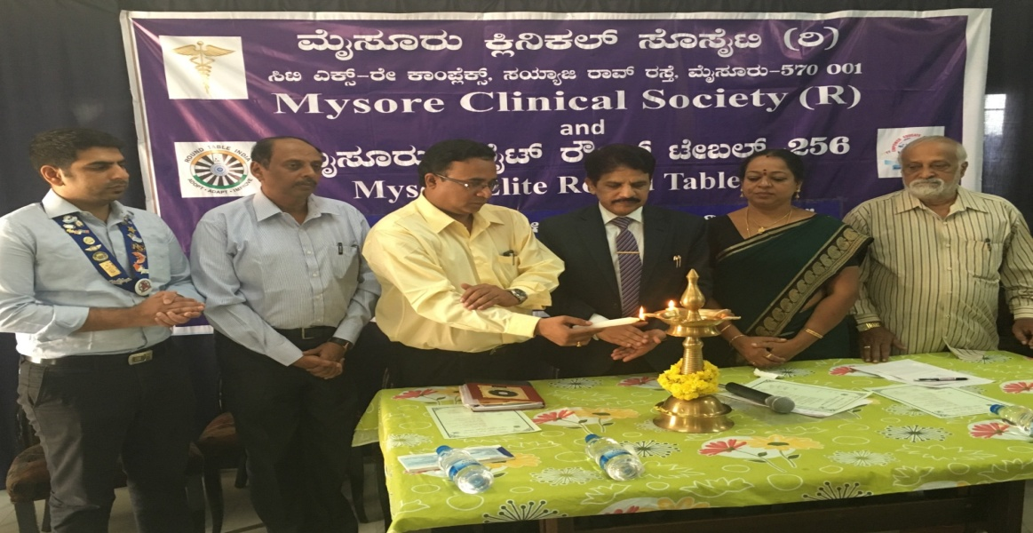

Mysore Clinical Society, in association with Mysore Elite Round Table-256 a Free De-worming celebration & Free Medicine Camp was conducted at Mediwave IVF & Fertility Research Hospital, Mysore.

From left
Dr S Ravikumar, Chairman, Mysore Elite Round Table-256, Dr. M.S. Vishveshwara, Superintend, Bharath Cancer Hospital, Dr. S. Gopinath, Reproductive & Child Health (RCH) officer, Dr.C. Sharath Kumar, Director & Chief Fertility Surgeon, Mediwave IVF & Fertility Research Hospital, Mysore, Smt.Dr. Sujatha S. Rao, Obstetric & Gynecologist, Dr.M.G.RUrs Rajyothsava Awardee, Govt. Of Karnataka Can be seen in the picture.

Photo Caption:
Picture-2
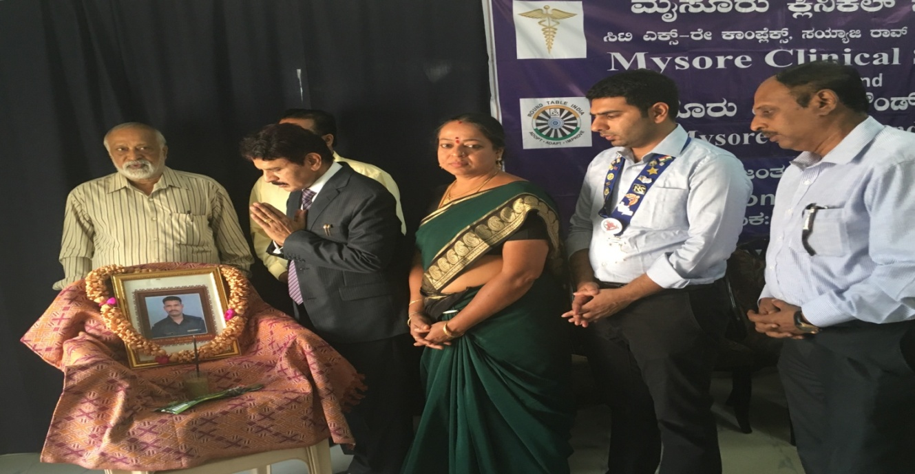

Mysore Clinical Society (R), in association with Mysore Elite Round Table-256 a Free De-worming celebration & Free Medicine Camp was conducted at Mediwave IVF & Fertility Research Hospital, Mysore. The Brave Soldier Hanumantahppa Koppad who took his last breath after surviving the avalanche at Jammu Kashmir, Siachen, given a minute’s silence.

From left
Dr.M.G.RUrs Rajyothsava Awardee, Govt. Of Karnataka Mysore, Dr. S. Gopinath, Reproductive & Child Health (RCH) officer, Dr.C. Sharath Kumar, Director & Chief Fertility Surgeon, Mediwave IVF & Fertility Research Hospital, Mysore, Smt.Dr. Sujatha S. Rao, Obstetric & Gynecologist, Dr S Ravikumar, Chairman, Mysore Elite Round Table-256, Dr. M.S. Vishveshwara, Superintend, Bharath Cancer Hospital,

Photo Caption:
Picture-3

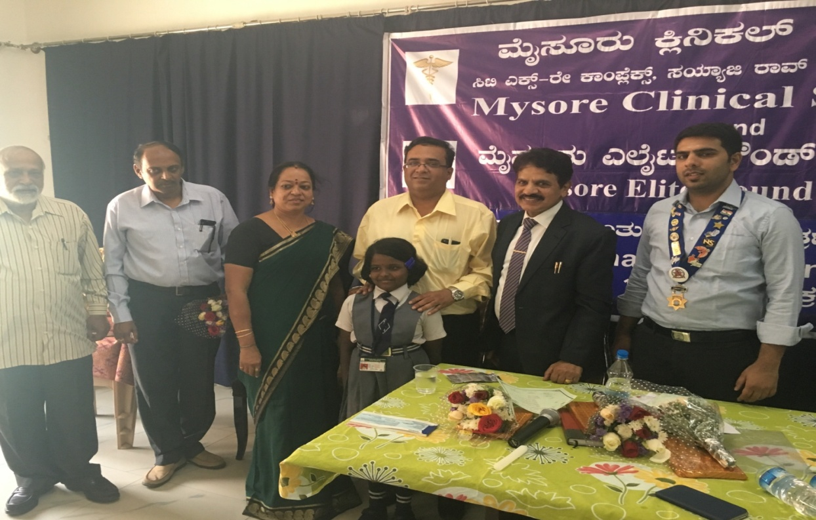

From left
Dr.M.G.RUrs Rajyothsava Awardee, Govt. Of Karnataka Mysore, Dr. M.S. Vishveshwara, Superintend, Bharath Cancer Hospital, Smt.Dr. Sujatha S. Rao, Obstetric & Gynecologist, Dr. S. Gopinath, Reproductive & Child Health (RCH) officer, Dr.C. Sharath Kumar, Director & Chief Fertility Surgeon, Mediwave IVF & Fertility Research Hospital, Mysore, Dr S Ravikumar, Chairman, Mysore Elite Round Table-256 Can be seen in the picture.

Photo Caption:
Picture-4

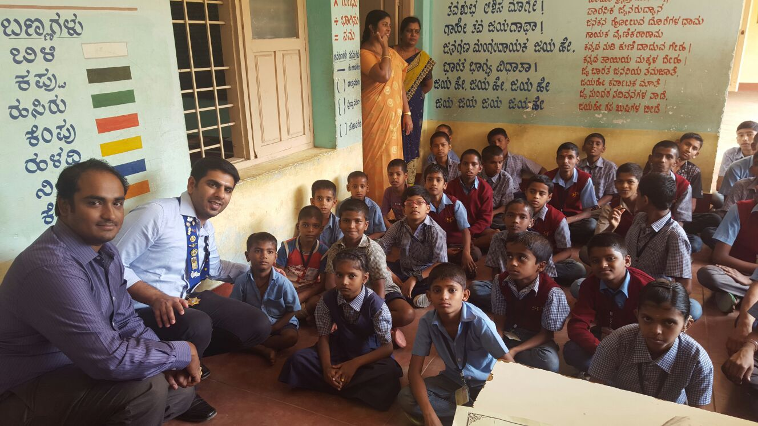

After the Programme free medication was provided to 60 students at “Shravana Dhoshavulla Makkala Sarkari Shaale” at Tilak nagar, Mysuru, and also for 30 students at Metagalli Govt. Higher Primary School by Mysore Clinical Society (R), in association with Mysore Elite Round Table-256 a.

From left
Tr. Kushal, secretary, Mysore Elite Round Table and Dr S Ravikumar, Chairman, Mysore Elite Round Table-256 Can be seen in the picture.

Yours faithfully

(Dr.M.G.R.Urs)
Hon.Secretary

