For Kind Publication Date: 09.9.2015

In this modern technologically advanced world there are many causes which lead towards Infertility in couples. Physical attributes, mental attributes, inter family marriage, environmental pollution; vegetation using chemicals, drinking, smoking etc are some factors which are responsible for the increase in percentage of Infertility among couples as said by Dr.C.Sharath Kumar, Director, Chief Fertility Surgeon, Mediwave IVF & Fertility Research hospital Mysuru.
The Free Infertility Checkup camp presided with help of Dr.C.Sharath Kumar was held by Mysore Clinical Society in association with Mysore University Zoological Department at Mediwave IVF & Fertility Research Hospital in Sayyaji Rao Road, Mysuru.
These following factors were main features of the camp which were addressed and promised to deliver the results for free of cost.
Life is very short. The main purpose of all living things on earth is to reproduce. Likewise, we human beings are bound by our duty to reproduce. Reproduction is the art of producing new organisms that is the process whereby life is continued from one generation to other. Parenting a child is one of the best feelings in the world. But unfortunately, some of the couples are deprived of this opportunity because infertility problems said Dr. C Sharath Kumar.
Infertility is the inability to conceive and become pregnant after 12 months of regular, unprotected sex. If a couple does not conceive after a year of effort, it is likely that the man, the woman, or both partners are infertile. Infertility affects men and women equally said Dr. C Sharath Kumar.
Infertility affects 10-15% of all married couples. 80% of couples conceive within a year. Another 5-10% Conceive in the subsequent years (within 2-3 Years) and the rest remain infertile. Conception and pregnancy are complicated processes involving many biologic factors. A man should produce healthy sperm and a woman healthy egg; the cervical mucus should be healthy and abundant so that the sperm travels through the cervical canal to the uterus and fallopian tubes; the fallopian tubes opens so that the sperm can reach the egg; the sperm fertilizes with the egg and the fertilized egg (the embryo) implants in the woman’s womb and the outcome is a beautiful baby. While this may seem simple, but if any one of the biologic factors is impaired or damaged in any way, infertility can result said Dr. C Sharath Kumar.

Infertility is classified into two types:
Firstly, when there is no pregnancy has ever occurred. Approximately 70% of infertile couples have primary infertility. Secondly when there has been a previous pregnancy regardless of the outcome. Approximately 30% of couples have secondary infertility.
In approximately 42% of infertile couples, the cause is identified in male and in 36% the cause is identified in female and in about 10% of couples; causes can be detected in both partners. In about 10% of cases, it is not yet found by the current diagnostic methods. It is known as unexplained infertility said D. C Sharath Kumar.
Dr.B.Basavaraju, District Health Officer, Mysuru District, Mysuru inaugurated the “Free Infertility Checkup Camp”.
Rest of the Chief guests who were present at the camp were Dr.M.G.R.Urs, Hon.ble Secretary, Dr.Kalal Iravathy Goud, HOD, Dept. of Molecular Biology and Cytogenetic, Apollo Hospital, Hyderabad, Prof. Rachel Jesudasan, Scientist, CCMB, Hyderabad, Dr.S.S.Malini, Molecular Reproductive and Human Genetic Laboratory, Department of Zoology, University of Mysore. Dr. C.Sharath Kumar, Director & Chief Fertility Surgeon, Mediwave IVF & Fertility Research Hospital, Mysuru, Dr. Usha Dutta, Cytogeneticist CDFD Centre for DNA Finger Printing & Diagnostics, Hyderabad.

Photo Caption
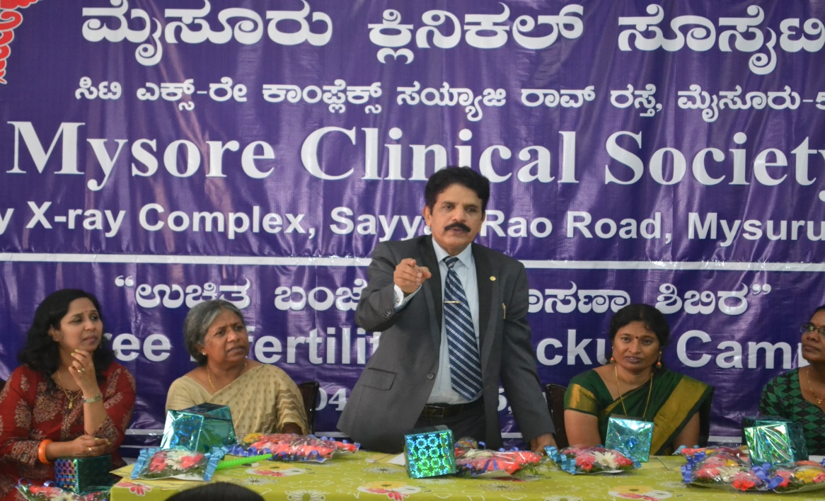

Speech Being Delivered Dr. C.Sharah Kumar, Director, & Chief Fertility Surgeon, Mediwave IVF & Fertility Research Hospital, Mysuru at “Free Infertility Checkup Camp” organized by Mysore Clinical Society (R), on 04.9.2015, Friday at Mediwave IVF & Fertility Research Hospital, Mysuru
Others seen in the picture are (From Left) Dr.Kalal Iravathy Goud, HOD, Dept. of Molecular Biology and Cytogenetic, Apollo Hospital, Hyderabad, Prof. Rachel Jesudasan, Scientist, CCMB, Hyderabad, Dr.S.S.Malini, Molecular Reproductive and Human Genetic Laboratory, Department of Zoology, University of Mysore, Dr. Usha Dutta, Cytogeneticist CDFD (Centre for DNA Finger Printing & Diagnostics, Hyderabad.

