For Kind Publication Date: 26/01/16
“India towards Global Power – Dr.CSK”
India has taken over china in terms of global economic position and stands 3rd in world economy. Stands 1st in software generation in the world and Contributes 51% for global software needs. Leading in pharmaceutical industry one of the best in medical treatment and services. 2nd largest English speaking country, said Dr.C. Sharath Kumar, Principal of Mediwave Institute of Medical Science, Mysore and Honorable President of Genius Friends Association.
Dr. C. Sharath Kumar Hoisted the Indian National Flag On the occasion of 67th Republic Day and Blood Donation Camp was conducted on 26th January 2016, 9:30am Tuesday, at Mediwave IVF & Fertility Research Hospital, in association with Genius Friends Association and Mysore Elite Round Table-256.
India is developing dynamically in all terms and to add further Indian Army stands 2nd in global world ranking, Indian Navy and Indian Air force stands 5th in global world ranking as said by Dr. CSK.

This camp was inaugurated by Dr. M.G.R Urs Rajyothsava Awardee, Govt. of Karnataka. &
Dr Ananya Sampath Founder Member, GFA Spoke about the Importance of Blood Donations
This camp was presided by Dr S Ravi Kumar, Chairman Mysore - Elite Round Table 256 and other chief guests who shared the stage were Tr. Khailash Area Chairman, Area13, Round Table India and Dr C. N. Ravi Kumar Dean & HOD, Dept. Of C.Sc. SJCE, Mysuru.
This Blood Donation Camp was Run Successfully with the help of J.S.S Hospital, and in this camp Members of genius friends association volunteered and around 40 people donated blood.
Welcome speech on the occasion was delivered by C. Deepak, Founder of Genius Friends Association and vote of thanks was delivered by Kumari Suprabha.
All the staff and office bearers of Mediwave Institute of Medical Sciences, Members of GFA, Members of Elite Round table-256, and staff of blood bank of JSS were present there for the celebration and sweets were distributed among all.
P.T.O

Photo Caption
Picture 1 Flag Hoisting
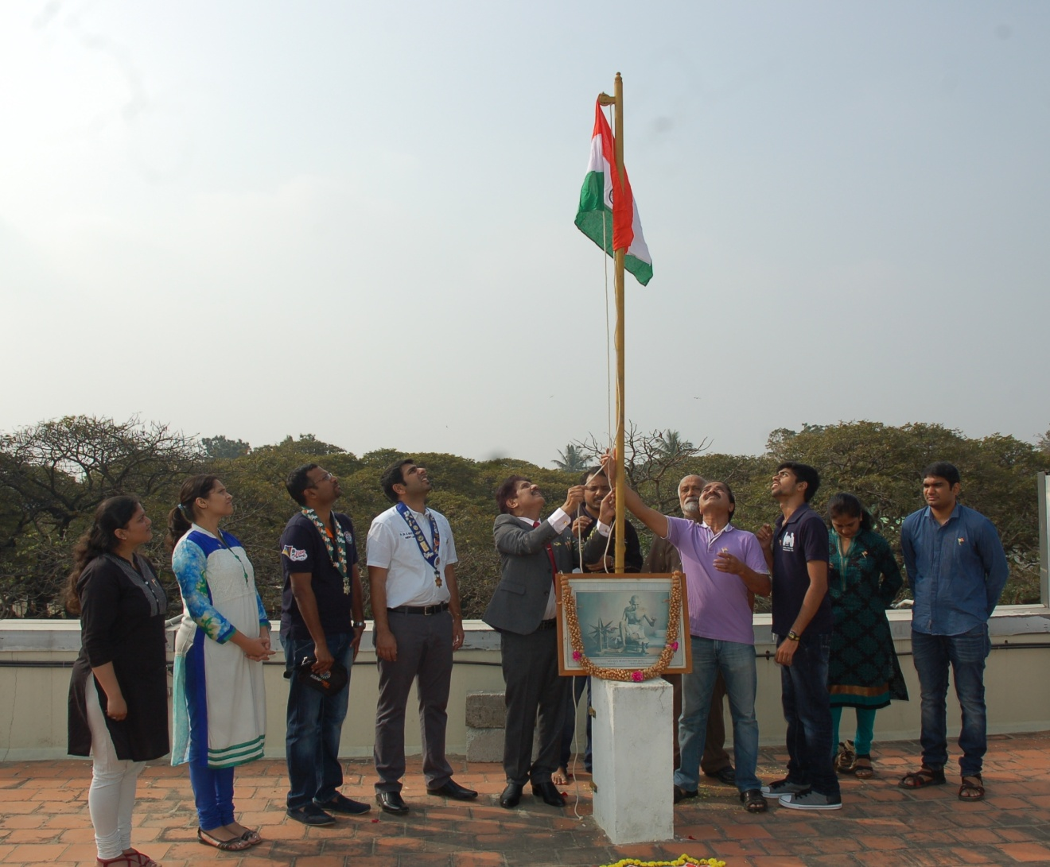
Dr C Sharath Kumar Principal of Mediwave Institute of Medical Science, Mysore and Honorable President of Genius Friends Association, Hoisted the Indian National Flag On the occasion of 67th Republic Day and Blood Donation Camp was conducted on 26th January 2016, 9:30am Tuesday by Genius Friends in Association with Mysore Elite Round Table-256 at Mediwave IVF & Fertility Research Hospital, city X-Ray Complex Sayyaji Rao Road, Mysuru
From Left:
Dr. Pallavi Prakash, Dr. Prityanka Ravi Kumar, Tr. Khailash Area Chairman, Area13, Round Table India, Dr S Ravi Kumar Chairman Mysore - Elite Round Table 256, Dr. M.G.R Urs Rajyothsava Awardee, Govt. of Karnataka

Picture 2 Inauguration
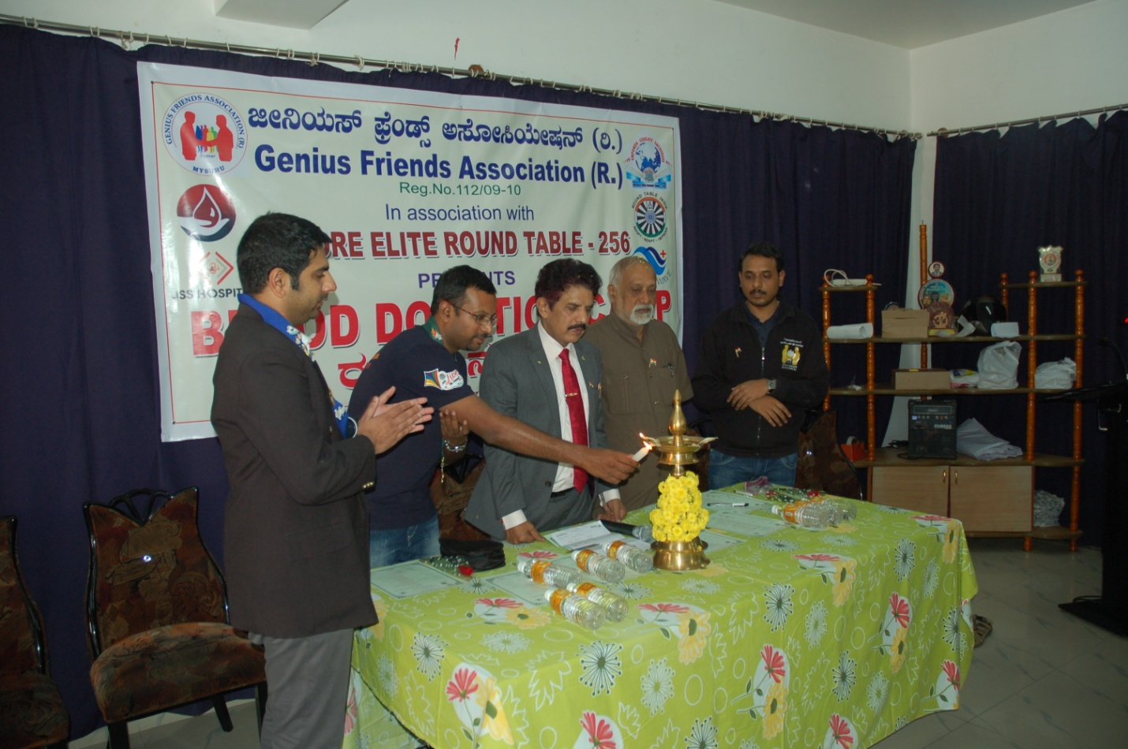
On the occasion of 67th Republic Day and Blood Donation Camp was conducted on 26th January 2016, 9:30am Tuesday by Genius Friends in Association with Mysore Elite Round Table-256 at Mediwave IVF & Fertility Research Hospital city X-Ray Complex Sayyaji Rao Road, Musuru
From Left
Dr S Ravi Kumar Chairman Mysore - Elite Round Table 256, Tr. Khailash Area Chairman, Area13, Round Table India, Dr C Sharath Kumar Principal of Mediwave Institute of Medical Science, Mysore and Honorable President of Genius Friends Association, Dr. M.G.R Urs Rajyothsava Awardee, Govt. of Karnataka, C. Deepak, Founder of Genius Friends Association can be seen in the picture.

(Dr S Ravi Kumar)
Chairman
Mysore - Elite Round Table 256

