ESTD:1990
MYSORE CLINICAL SOCIETY (R)
City X-Ray Complex, New Sayyaji Rao Road, Mysore – 570 021
PH: 0821-2444441, 3265002.
Email: drsharath@hotmail.com. Website: www.mediwave.net.

For Kind Publication Date: 04.5.2016

Approximately 2 crores people in India are suffering from Asthma- Dr C S K.

Approximately 25% of Indians are Allergenic, in which 5 are suffering from allergies related to Asthma. Approximately 2 crores people in India are suffering from Asthma. Based upon the current situation Asthma will be recorded as the top 1 epidemic disease in India by 2060. Almost 55% of the budget allocated for Societal Health and Welfare Ministry would be kept dedicated in treating Asthma by that time, Said
Dr.C. Sharath Kumar, Director & Chief Fertility Surgeon, Mediwave IVF & Fertility Research Hospital.

“World Asthma Day” & “Round Table India Chartered Day” was celebrated jointly by Mysore Clinical Society(R), & Mysore Elite Round Table-256, on 06.05.2016, Friday at Mediwave IVF & Fertility Research Hospital Auditorium, Sayyaji Rao Road, City X-Ray Complex, Mysore- 570021.

The first World Asthma Day was celebrated in the year 1998. According to World Health Organization the first Tuesday of May, every year is noted as World Asthma Day, adjoining the whole is Asthma Awareness Month would be celebrated. According to 2014 records 33.4 crores people in world are suffering from Asthma and it brings about “Chills in the Minds” of people, thinking about the percentage of children suffering from Asthma in Bangalore, and has increased from 2% to 28% in our capital city from last
15 years said Dr. C S K.

The Chief Guest for the occasion, Shri Amshi Prasanna Kumar Associated Editor, Kannada Prabha, Mysuru, said that our capital city Bangalore is being noted as the Asthma Capital of India. The main reason for this can be observed as pollution and desperate measures have to be taken in creating awareness and bring about control over the situation.

Shri N.S. Mahesh, Asst. Director Information & Publicity Department, Mysore,
Dr. S.S.Malini, Molecular Reproductive and Human Genetic Laboratory, Department of Zoology, University of Mysore, Dr.M.G.RUrs Rajyothsava Awardee, Govt.Of Karnataka, Dr. Priyanka Ravikumar, Obstetrician & Gynecologist, Mediwave I.V.F & Fertility Research Hospital, Dr S Ravikumar, Chairman, Mysore Elite Round Table-256, were also a part of the dais for the occasion.

Photo Caption
On the occasion which marked the World Asthma Day celebration, for which,
Shri N.S. MAHESH, Asst. Director Information & Publicity Department, Mysore is seen inaugurating the camp held at Mediwave IVF & Fertility Research Hospital Sayyaji Rao Road, City X-Ray Complex, Mysuru 570001, people seen in the picture are as follows:

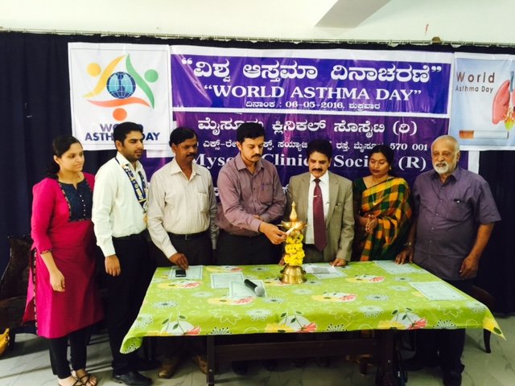

From Left to right:
Dr. Priyanka Ravikumar, Obstetrician & Gynecologist, Mediwave I.V.F & Fertility Research Hospital, Dr S Ravikumar, Chairman, Mysore Elite Round Table-256,
Shri. AMSHI PRASANNA KUMAR Associated Editor, Kannada Prabha, Mysuru,
Shri. N.S. MAHESH, Asst. Director Information & Publicity Department, Mysore,
Dr.C. Sharath Kumar, Director & Chief Fertility Surgeon, Mediwave IVF & Fertility Research Hospital, Dr. S.S.Malini, Molecular Reproductive and Human Genetic Laboratory, Department of Zoology, University of Mysore &
Dr.M.G.RUrs Rajyothsava Awardee, Govt.Of Karnataka.
Yours Faithfully
Dr M G R Urs
(Honorable Secretary)

