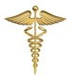
ESTD: 1990 Ph: 0821-2444441
MYSORE CLINICAL SOCIETY (R)
City X-Ray Complex, Sayyaji Rao Road, Mysuru-570 021

E-mail:drcsharath@hotmail.com, website: www.mediwave.net

For Kind Publication Date: 07.04.2016

“World Health Day 2016: WHO calls for global action to halt rise in and improve care for people with diabetes” – Dr C.S.K

World Health Organization (WHO) is marking its annual World Health Day (7 April), which celebrates the Organization’s founding in 1948, by issuing a call for action on diabetes. In its first “Global report on diabetes”, WHO highlights the need to step up prevention and treatment of the disease, said Dr.C. Sharath Kumar, Director& Chief Fertility Surgeon, Mediwave IVF & Fertility Research Hospital.

“World Health Day” was celebrated jointly by Mysore Clinical Society(R), Mysore Elite Round Table-256 & Mysore Elite Ladies Circle-141, on 07.04.2016, Thursday at Mediwave IVF & Fertility Research Hospital Auditorium, Sayyaji Rao Road, City X-Ray Complex, Mysore- 570021.

On this occasion a Free Breast Cancer Screening Camp was organized.

Diabetes is due to either the pancreas not producing enough insulin or the cells of the body not responding properly to the insulin produced. There are three main types of diabetes mellitus of which Type -1 is Juvenile Diabetes which is insulin depended, Type-2 is Adult onset diabetes and Type -3 diabetes or Gestational diabetes, is the third main form and occurs when pregnant women without a previous history of diabetes develop a high blood-sugar level according to Dr.C.S.K in his presidential address.

Diabetes caused 1.5 million deaths and the number of people living with diabetes and its prevalence are growing in all regions of the world, it is now 8.5% of the populations have diabetes said Dr. C.S.K.

The camp was inaugurated by Dr. M.S. Vishveshwara, Senior Specialist, Bharat Cancer Hospital Mysuru, said that people are going against the nature and its make, creating imbalances of lives externally as well as internally, a major proliferation in the lifestyles, and also being shy or not open in communication towards breast screening tests and medication, can be observed among men and women, which would lead to Breast Cancer and would cause highly related risk factors towards health and well being.

Chief Guests For the occasion was Sri Jainahalli Sathyanarayana Gowda, General Secretary, Jnanabutthi Organization.

Guest of Honor present for the occasion was Cr. Sanjana Thimaiah, Chairperson,
Mysore Elite Ladies Circle 141.

Dr. S.S.Malini, Molecular Reproductive and Human Genetic Laboratory, Department of Zoology, University of Mysore,
Dr. S. Ravikumar Chairman, Mysore Elite Round Table-256, Dr.M.G.RUrs Rajyothsava Awardee, and
Dr. Priyanka Ravikumar, Obstetrician & Gynecologist, Mediwave I.V.F & Fertility Research Hospital, Mysore, were also present for the occasion.

In the camp Digital X-ray Screening towards breast cancer, was provided for nearly 25 men and women who were in need, free of cost.

Photo Caption
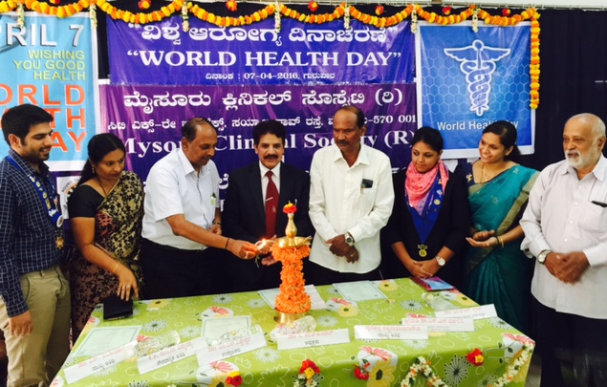
On the occasion which marked the World Health Day celebration, for which,
Dr. M.S. Vishveshwara, Senior Specialist, Bharat Cancer Hospital Mysuru,
is seen inaugurating the camp held at Mediwave IVF & Fertility Research Hospital Sayyaji Rao Road, City X-Ray Complex, Mysuru 570001, people seen in the picture are as follows

From Left to right:
Dr S Ravikumar, Chairman, Mysore Elite Round Table-256, Dr. S.S.Malini, Molecular Reproductive and Human Genetic Laboratory, Department of Zoology, University of Mysore, Dr. M.S. Vishveshwara, Senior Specialist, Bharat Cancer Hospital Mysuru,
Dr.C. Sharath Kumar, Director & Chief Fertility Surgeon, Mediwave IVF & Fertility Research Hospital, Sri Jainahalli Sathyanarayana Gowda, General Secretary, Jnanabutthi Organization, Cr. Sanjana Thimaiah Chairperson, Mysore Elite Ladies Circle 141,
Dr. Priyanka Ravikumar, Obstetrician & Gynecologist, Mediwave I.V.F & Fertility Research Hospital, & Dr.M.G.RUrs Rajyothsava Awardee, Govt.Of Karnataka.

Yours Faithfully
Dr M G R Urs
(Honorable Secretary)

