Diabetes is fast gaining the status of a potential epidemic in India with more than 62 million diabetic individuals currently diagnosed with the disease- said Dr C.S.K

Diabetes is due to either the pancreas not producing enough insulin or the cells of the body not responding properly to the insulin produced. There are three main types of diabetes mellitus:

- Type 1 DM results from the pancreas's failure to produce enough insulin. This form was previously referred to as "insulin-dependent diabetes mellitus" (IDDM) or "juvenile diabetes". The cause is unknown.

- Type 2 DM begins with insulin resistance, a condition in which cells fail to respond to insulin properly. As the disease progresses a lack of insulin may also develop.^{[6]} This form was previously referred to as "non insulin-dependent diabetes mellitus" (NIDDM) or "adult-onset diabetes". The primary cause is excessive body weight and not enough exercise.

- Gestational diabetes, is the third main form and occurs when pregnant women without a previous history of diabetes develop a high blood-sugar level According to Dr.C.Sharath Kumar, Director & Chief Fertility Surgeon, Mediwave IVF & Fertility Research Hospital, Mysore,
On the occasion of World Diabetes Day as observed on 20 November 2015, Friday, at Mediwave IVF & Fertility Research Hospital, in association with Mysore Clinical Society and Fourrts India laboratories Pvt Ltd, and Mysore Elite Round Table-256 a Free Diabetes Check up Camp was conducted.

There is no known preventive measure for type 1 diabetes.

Type 2diabetes can often be prevented by a person being abnormal, physical exercise, and following a healthful diet.
Dietary changes known to be effective in helping to prevent diabetes include a diet rich in whole grains and fiber, and choosing good fats, such as polyunsaturated fats found in nuts, vegetable oils, and fish.
Limiting sugary beverages and eating less red meat and other sources of saturated fat can also help in the prevention of diabetes.
Active smoking is also associated with an increased risk of diabetes, so smoking cessation can be an important preventive measure as well. As said by Dr C. S K

^{Photo Caption:}

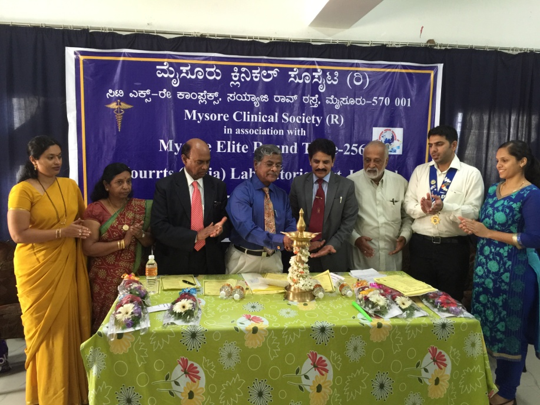

From left to right,
Smt.Malini, Asst Professor, Dept. Of Zoology, University Of Mysore,
Smt.ChutukuSiri Rathna Halappa Gowda, Thimaiah Rtd Director, Health & Welfare Office, Govt. Of Karnataka,
Dr. Lakshmi Narayan, Founder Sri Hari Diabetic Foundation, Kuvempu Nagar, Mysuru,
Dr C Sharath Kumar Director & Chief Fertility Surgeon, Mediwave IVF & Fertility Research Hospital, Mysore,
Dr.M.G.RUrs Hon. Secretary, Mysore Clinical Society,
Dr S Ravikumar, Chairman, Mysore Elite Round Table-256 &
Dr Priyanka Ravikumar OBG Specialist, Mediwave IVF & Fertility Research Hospital, Mysore,

