ESTD:1990 Ph:0821-2444441
MYSORE CLINICAL SOCIETY (R)
City X-Ray Complex, Sayyaji Rao Road, Mysuru-570 021

E-mail:drcsharath@hotmail.com, website: www.mediwave.net

For Kind Publication Date: 08.03.2016

Women are far Mentally Stronger than Men

Women may not be a physically stronger than men, but sure are mentally stronger than them. This has made them a “Go Getters” at all fields known and well versed by men. This attitude of women must be encouraged and provided an equal opportunity in the society. There are many names of women which have set the bars high at all fields, and these numbers should go even higher said Dr. S.S.Malini, Molecular Reproductive and Human Genetic Laboratory, Department of Zoology, University of Mysore.

“World Women’s Day” was celebrated jointly by Mysore Clinical Society(R) and Mysore Elite Round Table-256 on 8.3.2016, Tuesday at Mediwave IVF & Fertility Research Hospital Auditorium, Sayyaji Rao Road, City X-Ray Complex, Mysore- 570001.
On this occasion a Free Medical Health Checkup Camp was organized.

Dr. Vedavathi, Member of Ayurvedic & Unani Registration Board, Govt. of Karnataka, Bangalore Presided the occasion, said that women belonging social service groups must be encouraged and to bring about revolutionary changes in the nation. Women should get educational as well as overall growth. And they can also adopt, adapt and improvise at any field of their work with dedication and encouragement working hand in hand in the society.

Dr. Priyanka Ravikumar, Obstetrician & Gynecologist, Mediwave I.V.F & Fertility Research Hospital, Mysore Chief Guest for the occasion, said that the first “World Women’s Day” was celebrated in 1909, after that every year on March 8th, it is being celebrated worldwide. In present societal conditions Men as well as Women should be treated equally and given a respectful status. She also highlighted the problems and complications which a woman can experience pre and post menopause.

On the same occasion, Dr.C. Sharath Kumar, Director & Chief Fertility Surgeon, Mediwave IVF & Fertility Research Hospital also spoke about, even having no syndromes which can lead to removal of uterus, it is being removed for commercial purposes by Some doctors and practitioners in this field having money in their minds have been caught committing such crimes in the state. A COD investigation has been ordered by the Government run organizations but till now no action has been taken regarding this, were one of the cries heard.

Several Social workers, Police Inspectors, have visited the Arasikere taluk, Gopalapura Gollarahatti, and have been successful in convincing the village male society from banishing the women from their houses, keeping them at remote non ventilated huts built far from their livelihood, at the time of their Menopause said Dr Csk.

Cr. Sanjana Thimaiah Chairperson, Mysore Elite Ladies Circle, was also present for the occasion as Guest of Honor.

Dr S Ravikumar, Chairman, Mysore Elite Round Table-256, Dr.M.G.RUrs Rajyothsava Awardee, and Chutuku Siri Rathna Haalappa Gowda, were also present for the occasion.

In this occasion Mrs. Shanthamma, presented the starting Adoration, Rathna Haalappa Gowda, Gave the welcome speech, and M. N. Umadevi, Gave the vote of thanks.

Photo Caption:

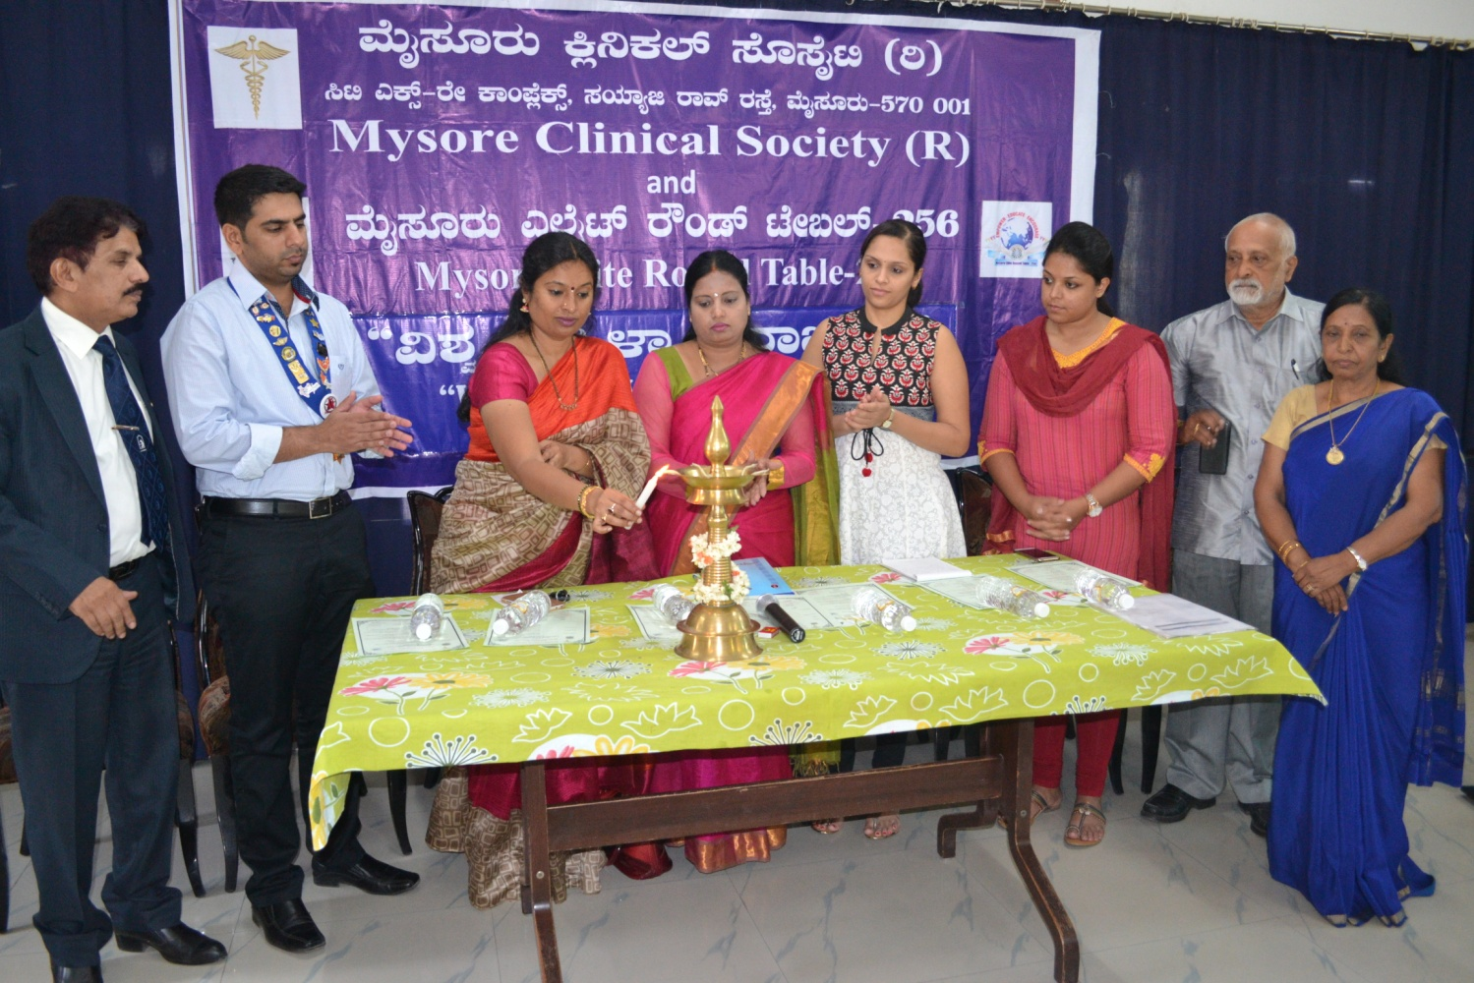

Mysore Clinical Society, in association with Mysore Elite Round Table-256
a “World Women’s Day” celebration & Free Medication and check up Camp was conducted at Mediwave IVF & Fertility Research Hospital, Mysuru.

From left,

Dr.C. Sharath Kumar, Director & Chief Fertility Surgeon, Mediwave IVF & Fertility Research Hospital, Dr S Ravikumar, Chairman, Mysore Elite Round Table-256, Dr. S.S.Malini, Molecular Reproductive and Human Genetic Laboratory, Department of Zoology, University of Mysore, Dr. Vedavathi, Member of Ayurvedic & Unani Registration Board, Govt. of Karnataka, Bangalore, Dr. Priyanka Ravikumar, Obstetrician & Gynecologist, Mediwave I.V.F & Fertility Research Hospital, Cr. Sanjana Thimaiah Chairperson, Mysore Elite Ladies Circle, Mysore, Dr.M.G.RUrs Rajyothsava Awardee, Govt. Of Karnataka, Chutuku Siri Rathna Haalappa Gowga,Can be seen in the picture.

